14th International Student Symposium
UC Clermont,
September 3, 2026

10 am – Welcome by UC Clermont (Victoria Appatova)

10:10 am – 12 pm – PRESENTATIONS (Snyder 142)

Faculty Presentations:
- Dr. Violeta Vidacek Hains
American and Croatian Students in Cross-Cultural Communication: Experiences and Perspectives
- Dr. Damir Vučić
Traditional and folklore elements as a tool of developing skills in communication and storytelling

Student Presentations:
- Niko Rastija
In-depth Analysis of the Impact of Physical Activity on Student Mental Health in an International Environment
- Mihaela Sedlar
Intercultural Communication in Networked Society
- Dino Plodinec
The Impact of Physical Activity on the Mental Health of University Students

12-1 pm - LUNCH AND SOCIALIZATION – (Snyder 142; vouchers for the food truck will be provided)

1-2 pm – TRADITIONAL CROATIAN DANCE WORKSHOP (Krueger Auditorium)
Dr. Damir Vučić – The Application of Traditional Ethnological and Folklore Elements (Dance, Music, and Traditional Costumes) in Physical Education Classes for Children and Adults

2-3 pm – FACULTY AND STUDENT PANEL (Snyder 142).

3-3:30 pm – CAMPUS TOUR (starts in Snyder 142)



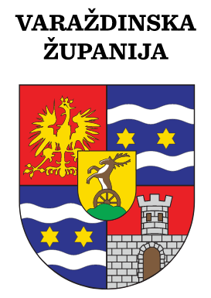

McNair Scholars Program

